Exercise 11: Upheaval Dome Virtual Field Trip

Geology Lab 111 Name__________________________________________________
Objectives:
- Learn about the geology of Canyonlands National Park
- Recognize and use learned terminology and ideas from structural geology, sedimentary rocks, igneous rocks, and mineralogy
- Learn how to assess and compare competing geological hypotheses
The virtual field trip is at
https://vft.asu.edu/VFTUpheavalDome/panos/UpheavalDome2020/UpheavalDome.html

For this you must:
- Allow Adobe Flash Player to work in your browser. Go to your browser’s preferences to do this. Look up how to do this if you don’t know how to do it.
- Have a good internet connection. This will not work in an offline environment at all.
- Do not click back on your browser. You will be taken out of the field trip.
- Know how to create a screenshot with your particular device. Look this up if you don’t know how to do it.
- When watching the videos, you may want to hit the “CC” button so it shows captioning. That might help you follow along especially if some of the words are unfamiliar (like the names of rock units). But do beware, I noticed that on the “Possible breccia” video the closed captioning mistook the spoken word for breccia as “wretches,” “Brett Jay,” and “brushes.”

For Everyone in the Group

Watch the introduction and tutorial videos and answer the following questions:
- This virtual field trip takes place where? What city is nearby? What state is this? What national park?

Place- U.S.A
City- Moab
State- Utah
National park- Canyonlands national park.

- What do most geologists think Upheaval Dome represents?

Represent a salt dome that impacted as remains of crater.

Then Click “Start Trip”
When you see this view
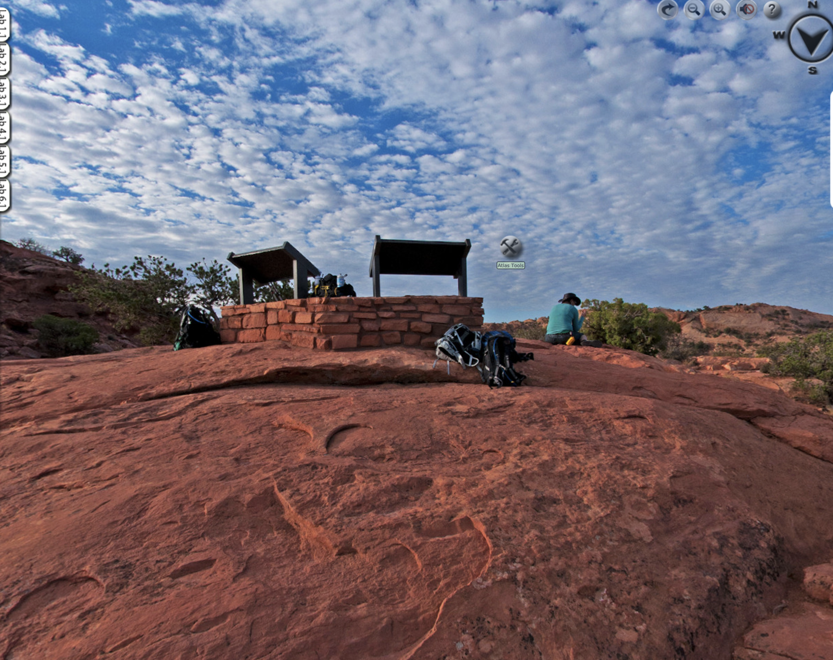
click on “Atlas Tools” near the middle of the image.
A popup subwindow in the lower left will appear.
Click on “Canyonlands GEO Atlas.”
Within this Atlas, find the answers to the following questions.
Under “Show me the rocks”
- Make a list of the 11 different sedimentary rock layers found in the Park. For each one list its name, age, and depositional environment. Go from top to bottom.
Name | Age—Years Ago and Period | Depositional Environment
Conglomerate | 9 years (2012-2021) | Alluvial fan
Tillite | 3 years (2018-2021) | Glacier till
Sandstone | 1 year (2020-2021) | Glacier outwash
Arkose | 8 years (2013-2021) | Alluvial fan
Anhydrite | 17 years (2004-2021) | Swallow restricted circulation in arid hot climate
Gypsum | 22 years (1999-2021) | Swallow restricted circulation in arid hot climate
Coal | 4 years (2017-2021) | Delta
Siltstone | 2 years (2019-2021) | Tidal flat
Mudstone | 16 years (2005-2021) | Tidal flat
Graywacke | 7 years (2014-2021) | Slope
Halite | 22 years (1999-2021) | Swallow restricted circulation in arid hot climate

- During what two geological Eras were the rocks in this area formed? Note, Eras are longer than Periods. You need to refer to the geologic time scale to answer this.
Mesozoic era-251.9 to 66 million years ago.
Paleozoic era- 554 to 252 million years ago.

- What rivers flow through the Park? Use the Interactive geologic map link
.
Green and Colorado rivers.

- In what district of the Park are there lots of faults? Use the Interactive geologic map link.

300million years ago.

- Explore the district from question 6 and answer the following:
  - When did the grabens form?
It is an elongated block of the earth crust lying between two faults and displayed downwards relatively to the surrounding rock.

  - How did the grabens form?
Grabens are formed from parallel normal faults where the displacement of hanging walls is downwards and that of the foot wall is upwards.

  - What is a graben? Insert a screenshot from this part of the material to illustrate your answer.

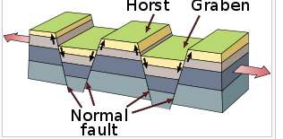

  - What kind of fault is associated with horsts and grabens? Look this up.
Normal faults.

  - What kind of stress did this area experience to form these faults, horsts, and grabens? You should remember this from what you learned about these faults.
Tensional stress/force.

Click out of the Canyonlands GEO Atlas and click the “Media” tab to close that subwindow.

Move the image over to the view over Upheaval Dome.
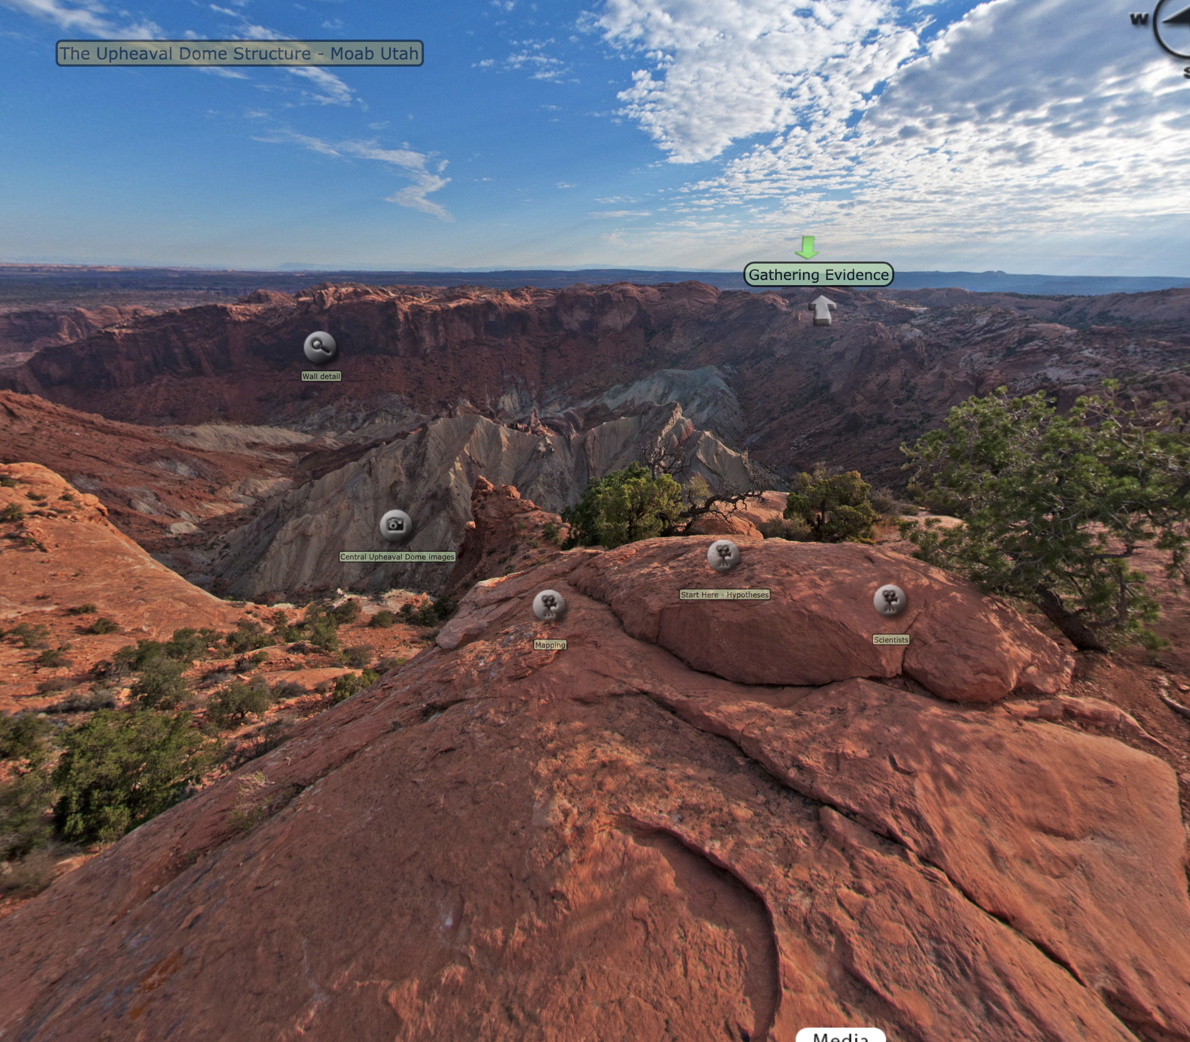
Near the middle of the image you will see “Start Here—Hypotheses.” Click on that.

Start Here--Hypotheses
- What led Gene Shoemaker to first think that Upheaval Dome might be an impact crater?

Because small impact craters typically have a simple bowl shape which look similar to upheaval dome.

- What is the salt dome hypothesis for the formation of Upheaval Dome? Watch the “Salt dome” video under Sediments for question #27 to better understand this idea.

States that the dome is a sign of a sub-surface salt which is arising plug of relatively low density salt that caused overlying rock layers to dome up in a circular pattern. The overlying rock were lifted then eroded leaving bull’s eye surface pattern.

- What is the name and age of the formation in this area that is made of salt and what is its stratigraphic position in the area (meaning is it a layer near the bottom, in the middle, or near the top of all the different sedimentary layers)?

Thick sandstone- Windgate formed at the middle.
Chinle –formed at the bottom.

- What is so special about the behavior of salt as a rock when it is buried under other rocks? Would you say the salt behaves in a brittle or a ductile fashion?

Starting from 1.3 to 1.5 below the surface the density of other rocks exceeds that of rock salt, density inversion takes place meaning that salt has a positive buoyancy when buried under other rocks at around 13 kilometer salt rises and intrudes into the overburden forming a diapir.

- What energy resource is associated with salt structures?

Renewable energy.

- Watch the Salt history video. In it, Dr. Hudec mentions the “Salt Men of Iran.” Check it out online and insert a picture of one of them here. Amazing.

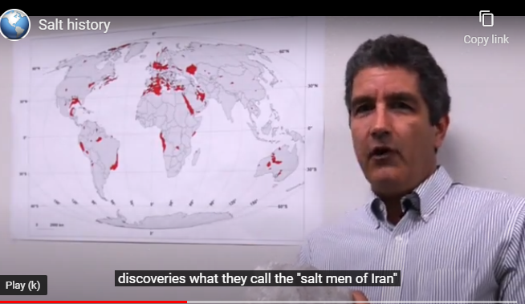

- In the Impact preference video, Dr. Hudec makes an assertion about the popularity of the impact hypothesis. What is it and do you think it is a reasonable assertion or one that involves emotion? Why or why not?

Meteor model which is very sexy its violent creatures when there was an impact.

Now click on Mapping to the left and watch “Dome problems”
- What did Dr. Hudec discover about the type of stress that formed the structures within Upheaval Dome after he mapped it?

Anticlinal arching.

- What problem did that cause for the salt dome hypothesis? Explain. What structures would form over a salt dome? (Look back at the answers in question 7—no salt dome there, but same type of stress. Also, check out this video.
https://www.youtube.com/watch?v=QzuhWYlg7wc

It makes it difficult/ contradict the salt dome hypothesis because in this case the dome is formed through anticlinal arching.
Features –Rift valley.

Close that subwindow and go to “Exploring the terrain.”
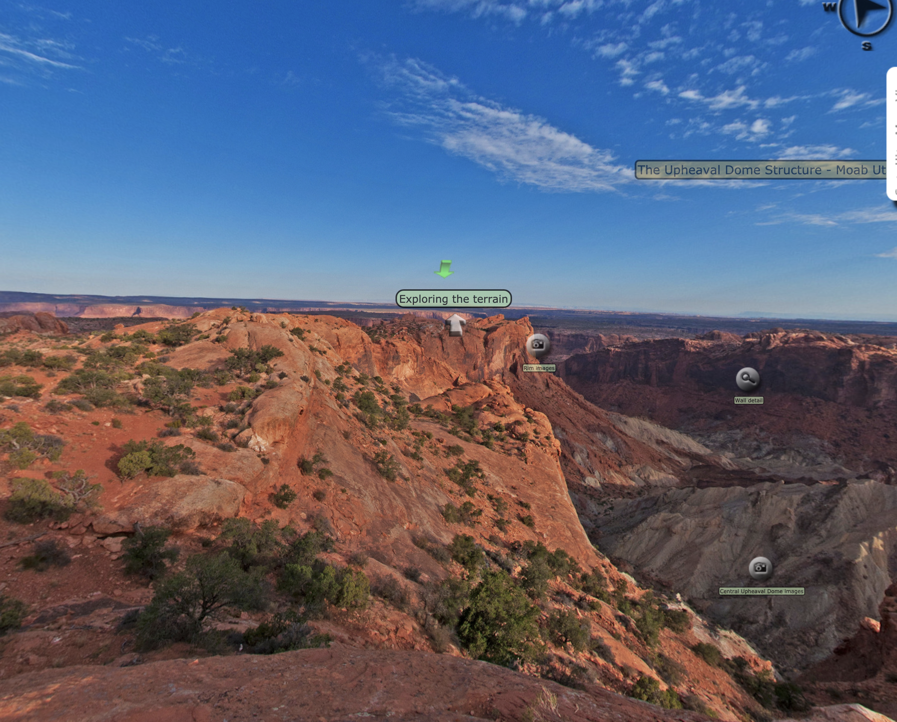

Exploring the terrain
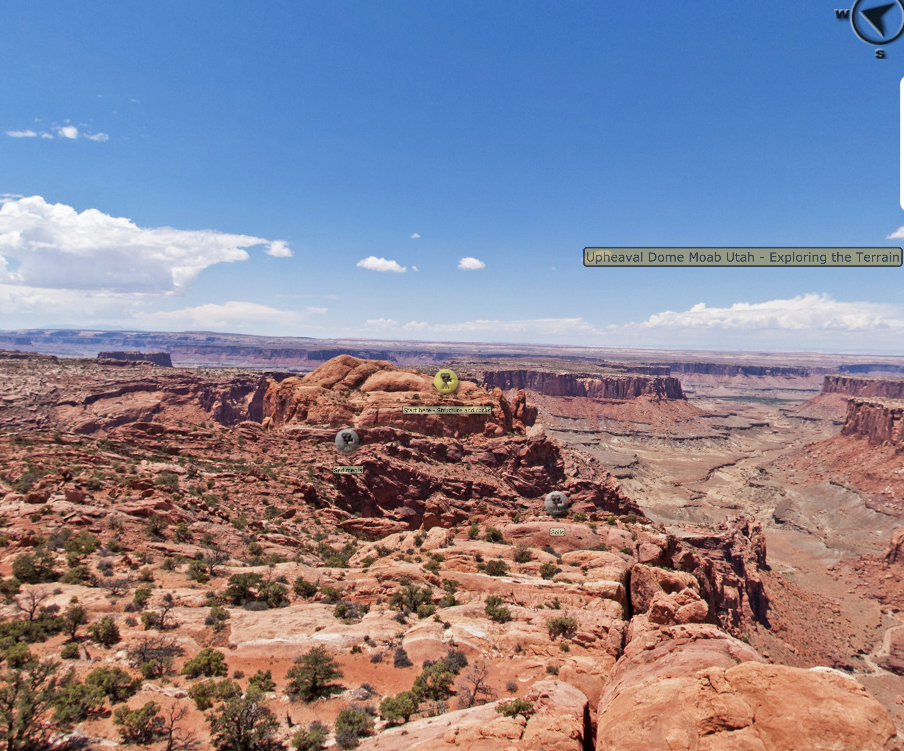
Click on “Start here—Structure and rocks.” Watch “Structure of the Colorado plateau” and “Thickness changes” to answer the following questions.
- Why is Upheaval Dome considered a dome?
Because the rocks here are higher than they are normally are in the rest of the region.

- According to Dr. Hudec, what kind of evidence would indicate that there was a salt dome structure at Upheaval Dome?

Presence of withdrawal basin meaning that all the rocks sitting on top of it sink down because the salt is leaving.

- Think about the age and position of the salt in this area. As the sediment of the overlying formations was deposited over millions of years, we would expect the salt to have behaved in the way that Dr. Hudec describes. What exactly does he say about the actual structure of the overlying rocks around Upheaval Dome? You can quote word for word here if you want (use the CC option for assistance).

Everything is just flat because the salt is not moving.

Click out of that and click on “Sediments” to the left and watch one of the videos about crossbedding, the “Desert varnish” video, the “Ground water erosion” video, and the “Salt dome” video to answer the following questions.

- Take a screenshot and insert it here to show what crossbeds are.

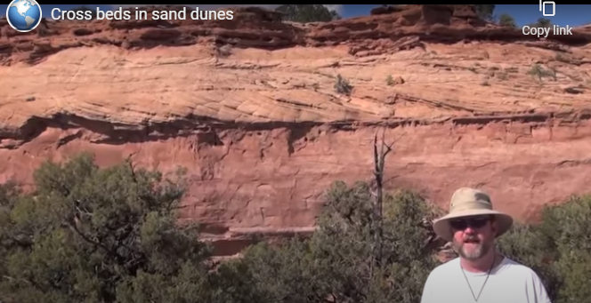

- How does crossbedding develop and what does it represent?

Develop when sediments are deposited by flowing wind or water and form a bedding that contain angled layers.
It represent separation of sediments into layers that differs from one another in texture, composition, color or weathering characteristics.

- What is desert varnish?

It’s a dark coating on rocks formed in arid areas.

- What is desert varnish made of?

Made of stable rocks surfaces that are no longer subject to frequent precipitation, fracturing or wind abrasion which compose of particles of clay along with iron and manganese oxide.

- What causes desert varnish to form?

Microbes which play an important role in allowing varnish to form.

- Why is there uncertainty regarding the formation of desert varnish?

Because some geologist think that there must have biology in the formation of desert varnish while others think there must have microbes which play an important role in allowing desert varnish to form.

- Would desert varnish be a definitive sign of microbial life on Mars if we discover desert varnish there?

No because it not yet proven.

- What is ground water sapping? Use the CC on this video to help you here if needed.

It is a geomorphic erosion process that result in the head ward migration of channel in response to near constant fluid discharge at a fixed point.

- Watch the Salt dome video and refer back to the answer from question 9. You can copy and paste that answer here to explain how a salt dome might have formed Upheaval Dome.

States that the dome is a sign of a sub-surface salt which is arising plug of relatively low density salt that caused overlying rock layers to dome up in a circular pattern. The overlying rock were lifted then eroded leaving bull’s eye surface pattern.

Click out of that and click on “Soils” to the right and watch the videos to answer the following questions.
- Get a screenshot of the cryptobiotic soils and insert it here.

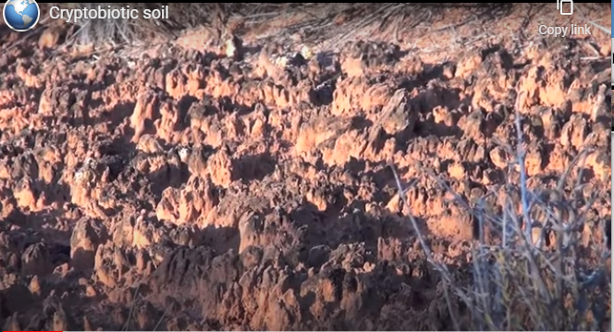

- What are cryptobiotic soils?

Is a type of soil consisting of soil cyanobacteria lichens and mosses which play important ecological roles in arid areas.

- What are stromatolites? Look it up. Insert a picture of the living ones found at Sharks Bay in Australia here to illustrate your answer.

Are geological structures that are being made by microbes they are essentially kind of living rocks.

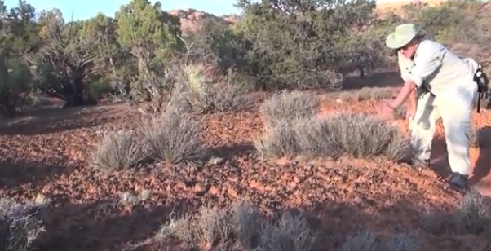

Click out of that and pan to the right.
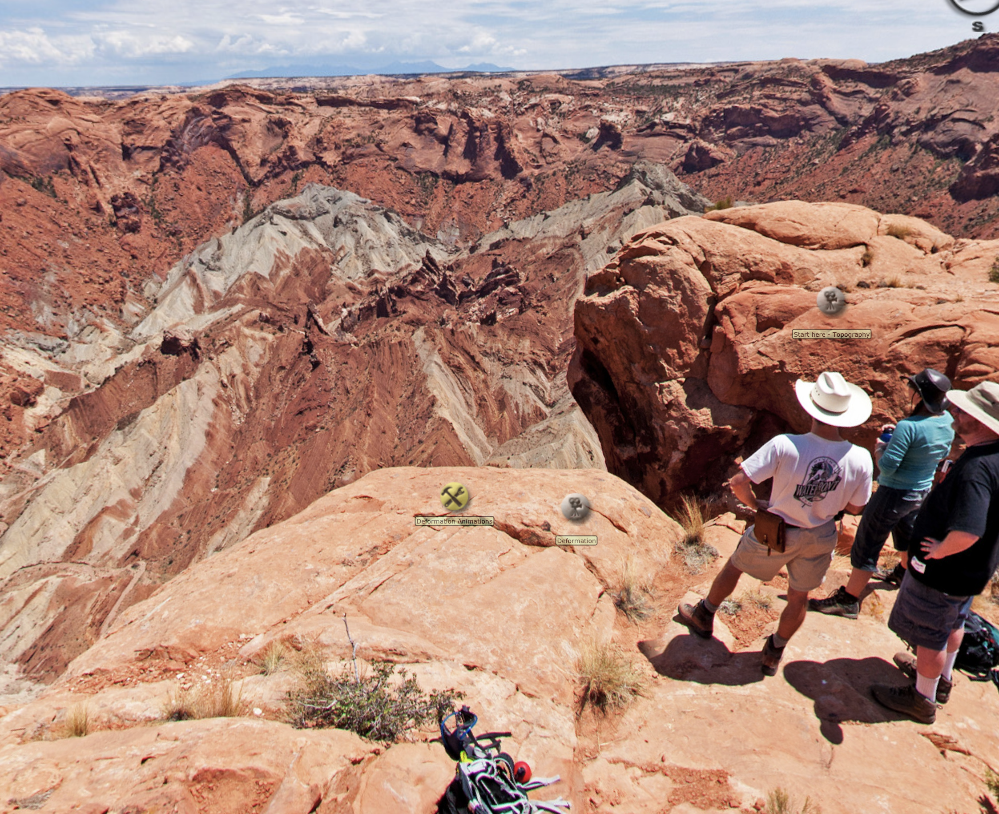
Click on “Deformation Animations” and watch the crater animation. Compare it to the video in this link https://www.youtube.com/watch?v=QzuhWYlg7wc on salt diapir (dome) formation and answer the following questions.

- How does the formation of an impact crater compare to the formation of a domed up area of a rising diapir of salt or to the area underneath a rising diapir of salt? Take screenshots and annotate them if you like to compare the two processes. Create extra space here if needed.

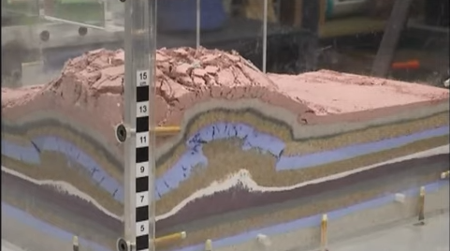

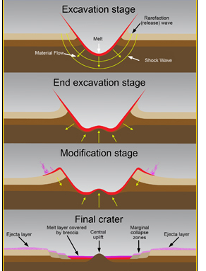

- Would you expect there to be more faults at the bottom of an impact structure compared to the area underneath a rising diapir of salt?
Yes because the anticlinal arching force in the impact structure leads to more formation of fault scarps than in the diaper of salt.

Click out of that and click on “Start here—Topography” near the man’s white hat and watch the videos to answer the following questions.
- What is going on with the White Rim Sandstone within the central part of Upheaval Dome as discussed in the “Ring syncline” video.

Exposure of the ring syncline toward the west down upheaval canyon, and then the far side of the canyon you can see an exposure of the ring syncline that is around this structure where the rocks dip down and then curve back up on the far side the faults that are dipping down in toward the center of the structure turn up to thrust faults.

- What is inverted topography?

Refers to land scape features that have reversed their elevation relative to other features. It mostly occurs when low areas land scape become filled with lava or sediments

- Why are the rock layers around the edge of the structure folded?

Because they are under compressional stress hence crumple in to folds.

Click out of that and click on “Deformation” to the right of “Deformation Animations” and watch the videos to answer the following questions.
- In the “Folded riverbed” video, take a screenshot of the folded sandstone he is talking about and insert it here.

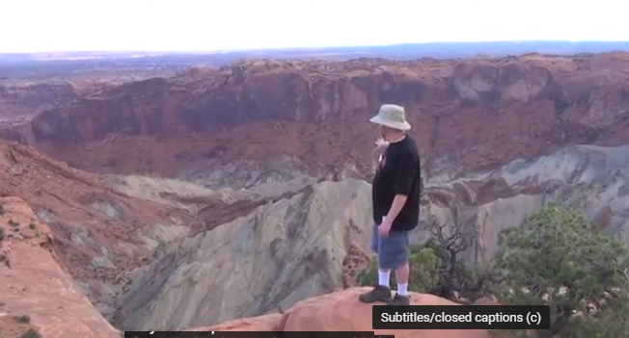

- In the “Thrust fault” video, take a screenshot of the thrust faults he is discussing and insert it here. Draw a line on it showing where you think one of the thrust faults is. A thrust fault is a low-angle type of reverse fault, so look for a fairly flat, but slightly inclined lineation that seems to separate overlapping layers of rock.

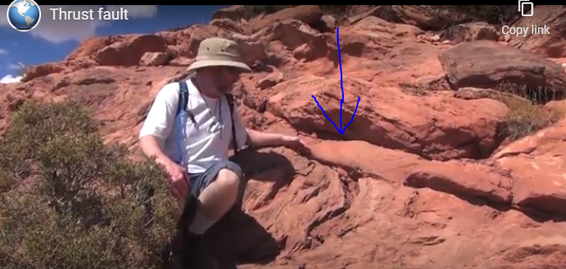

- What kind of stress causes folding and thrust faulting?

Compressional stress / forces

- Dr. Hudec discusses the pros and cons of impact and salt dome in three of the videos. What is his conclusion from the evidence?

There was an evidence in the ways units were deposited that there was actually a moving salt structure we can see thickening and thinning patterns which tells you there was a salt moving under and that things were going up and going down.

Go to Gathering Evidence.
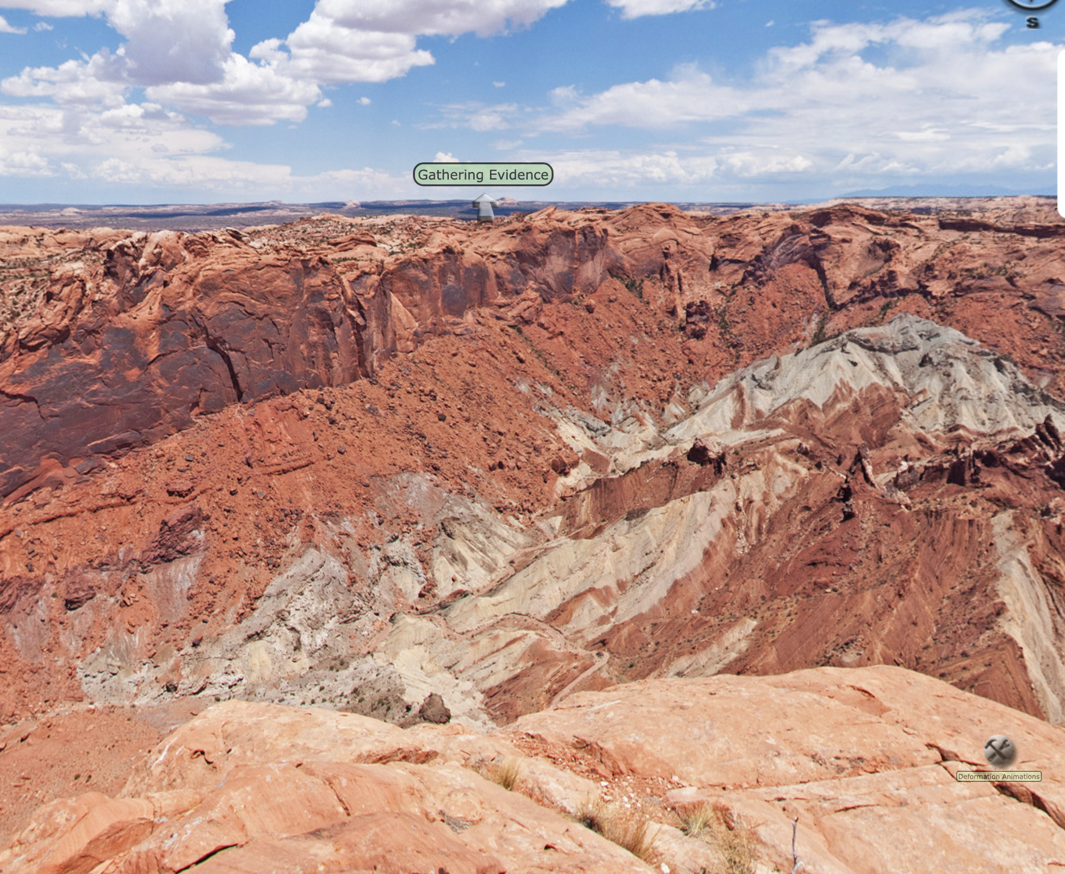
Gathering Evidence
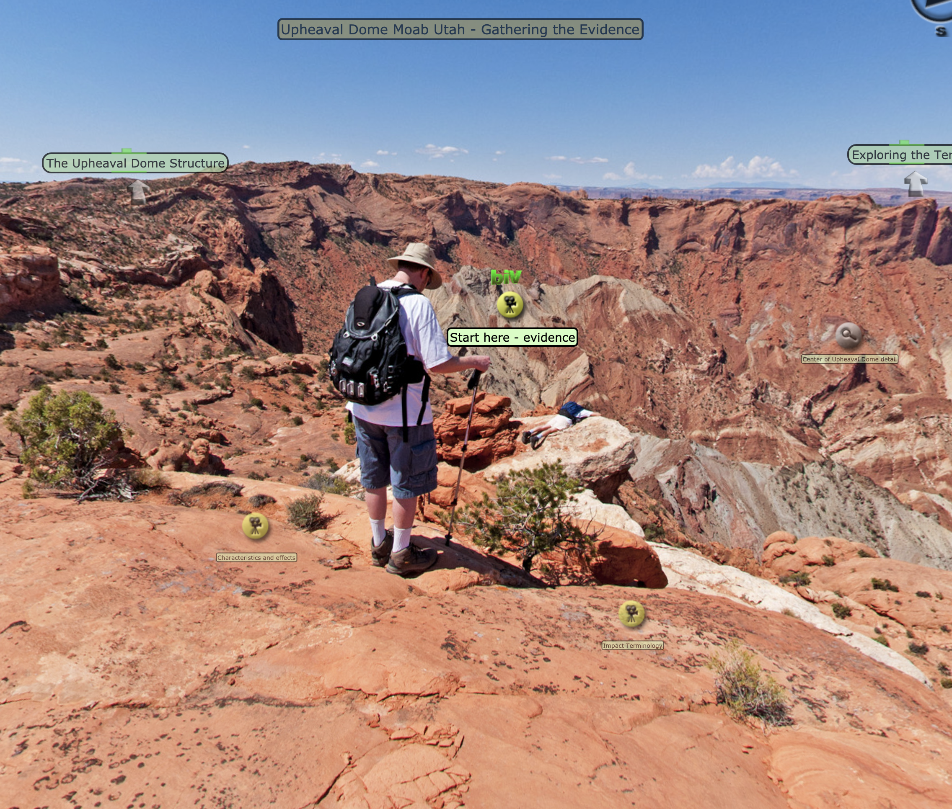
Watch the videos under “Characteristics and effects” and answer the following questions.

- How did erosion affect the crater in the impact crater model?

The rocks were deformed and broken that were easier to erode and so in millions of years since the impact those rocks have been eroded and carried out by water downstream out of the Green river.

- How do the salt dome people invoke the idea of erosion to support their model?

They suggested that over millions of years the salt will pierce and break through the overlying sediments first as a dome then through erosion it becomes a mushroom shaped fully formed diapir.

Click on “Fractures, faults, and features” to the right to watch videos to answer the following questions.
- What is shocked quartz and how is it evidence for an impact?
It’s a kind of deformation in a quartz that which is a mineral that you can get only in places where there has been a meteor impact

- Is there enough shocked quartz at Upheaval Dome to require formation by impact? Explain.

No because 2 grains out of 6000 is a little less convincing.

Go back to the area to the left (questions 41 and 42) and click on “Start here—evidence” to answer the following questions.
- What is the evidence for an impact at Upheaval Dome?

The rocks at the center have been very strongly deformed there. They folded and faulted as they are being compressed into the central uplift of a complex crater.
You can see Windgate sandstone in the cliff forming unit is thinner there and the rocks above it has been dropped down towards the center of the structure.

- What is the evidence for a salt dome forming Upheaval Dome?

The thickening and thinning patters which tells us there was salt moving underground and things were going up and going down.

- Discuss with your team what they thought about this and record your team’s conclusions here. It is fine to disagree. If you do, just briefly summarize why. If you feel no conclusion is possible, explain what you feel you would need to be convinced one way or the other.

In a nut shell, virtual field trips are much interactive as well as educative; they are also rich in educationally experiences. This is due to the fact that they were captured based on the real expeditions form the scientist who takes their research currently. We have other VFTs that are based on adaptive feedback as well as pathways. Their adaptively will allow nonlinear experiences based on varying pathways and individual feedback projected to the user responses and input. We also agreed that Virtual field trips are greatly used in colleges and high school classrooms in a way of supplementing a variety of topics which are as well being actively presented online.

